# ASSIGNMENT NO-1

Project Name: **IOT BASED SMART CROP PROTECTION SYSTEM FOR AGRICULTURE**

# Batch Number: B5-5M1E

**Assignment Topic**: smart home automation using sensor LEDs and buzzer

Team Lead : ARUN K

Team Member-1: KALAI SELVEN P Team Member-2: MANOJRAJ M Team Member-3: KAVIBHARATHI K

Before Simulation

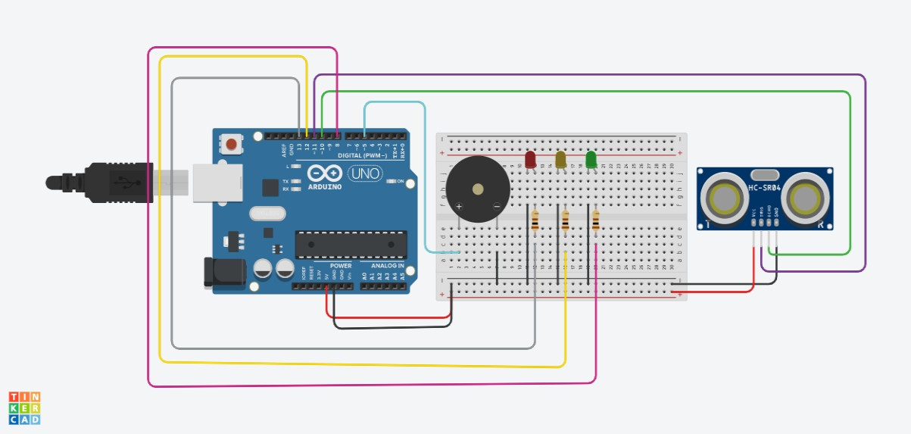

After Simulation

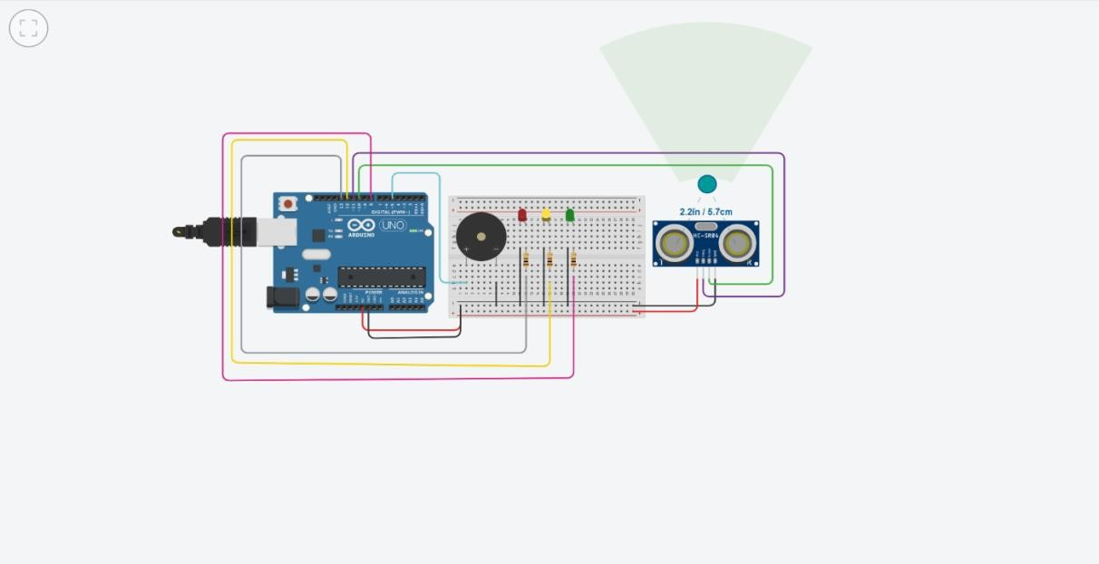

# Code:

